 ***Logo***:

SYMPHONY OF DESTRUCTION 2018: Project Plan

Date: 24-02-2018

**TEAM** for ProP Project:

Ivan Vasilev – 3452271

Kaloyan Krastev – 3342751

Valentin Spasov – 3331660

Lyudmil Naydenov – 3219359

**Table of Contents**

Project Statement 3

Formal Client 3

Project Leader 3

Current Situation 3

Problem Description 3

Project Goal 3

Project Deliverables and Non-Deliverables 4

Deliverables: 4

Non-deliverables: 4

Constraints 4

Constraint 1: 4

Constraint 2: 4

Constraint 3: 4

Constraint 4: 5

Constraint 5: 5

Risks 5

Risk 1: 5

Risk 2: 5

Risk 3: 5

Project Phasing 6

Project Phasing Big Format Photo 11

# Project Statement

In this chapter we will state why our project is started and what we will achieve. The following topics will be described: the client, the project leader, the initial situation, the problem description, the goal of our project, the deliverables and non-deliverables, the constraints and the risks.

# Formal Client

The client is a commercial company specialized in organizing events. They had been a part of various other companies. However, they decided to go solo from now on. The client contacted us in a need of a software solution that would help them manage their events.

Client Information:

Name: R. Gupta

Address: Fontys, Rachelsmolen 1, 5612 MA, Eindhoven

E-mail: [r.gupta@fontys.n](mailto:r.gupta@fontys.n)

# Project Leader

The project leader of our team is Ivan Vasilev and he is responsible for all communication between the project participants and the external parties.

Project Leader Information:

Name: I. Vasilev

Address: Fontys, Rachelsmolen 1, 5612 MA, Eindhoven

E-mail: [i.vasilev@fontys.nl](mailto:i.vasilev@fontys.nl)

# Current Situation

The client is in the event organizing business. They have been looking for an easier way to manage bigger events. They decided they would need a proper and good software system to manage those events. The verification and authentication of visitors has been faulty, and the client wants to improve the security of the event. Also, different sponsors want to sell their products at the events but there is no proper shop system implemented.

# Problem Description

The company currently uses an outdated system to manage all their information, they currently use excel sheets and have no way of managing the information properly. Managing data cross-platform is difficult, we will have to create a proper database which will have to be available to all the applications and the website. The client also would like additional functionality, security and reliability.

# Project Goal

The goal of this project is a working software solution containing various applications which help manage the event flow and a website for promotion and ticket buying.

• Make it possible to buy tickets online, get a parking spot, also reserve a place to stay

• Make software so that it is possible to check in visitors to the event

• Make it possible to use event currency through our technology to purchase goods

• Make loaning manageable through our technology and add steps to prevent theft

• Make it possible for the client to view various information regarding the event

• Store the data all in an online database, so that we have all the information we need available at all times

• Make a website to give users some additional pages to browse. (F.E. picture galleries of users / professionals and more.)

# Project Deliverables and Non-Deliverables

## Deliverables:

* agendas and minutes of every meeting
* a name and a logo for our event
* a project plan
* a database design
* an application to be used at the entrance of the event and camping area
* an application to be used at the shops
* an application to be used at the stand, where you can borrow materials
* an application to be used when a visitor leaves the event
* an application for the organization to inspect the status of the event
* an application to convert the information in the transaction-log-file to the database
* a website promoting events, allowing visitors to buy tickets and camping spots
* a form of identification for the visitors
* a course covering the usage of the software solution

## Non-deliverables:

* source code won’t be provided
* the software running on the ATM, that would be provided by the bank

# Constraints

## Constraint 1:

Time constraint:

Everything regarding the project must be finished before the final deadline of week 15.

## Constraint 2:

Database constraint:

The database must be an Oracle Database or MySQL.

## Constraint 3:

Hardware constraint:

The project must work with the bracelets provided to the visitors at the entrance of the event.

## Constraint 4:

Software constraint:

The apps must be developed in an Object-oriented language. The website can be developed in HTML, CSS, JavaScript, PHP… it is our choice to pick the technology behind the website.

## Constraint 5:

Language constraint:

We should use an international language like English.

# Risks

## Risk 1:

Risk in delivering a software which is 100% bug free

Probability: Low

Impact on project: Very High

Steps to prevent: Try to prevent bugs along the way, also leave enough time for proper bug testing.

Clean up action: Past-deadline bug removal.

## Risk 2:

Security breaches

Probability: Low

Impact on project: Very High

Steps to prevent: Use the latest version of all security systems.

Clean up action: None. It is impossible to fix the problem in a matter of hours.

## Risk 3:

Faulty hardware

Probability: Low

Impact on project: Very High

Steps to prevent: Stress test the hardware during the development phase to determine if it is up to the task.

Clean up action: On spot replacement for the damaged units.

# Project Phasing

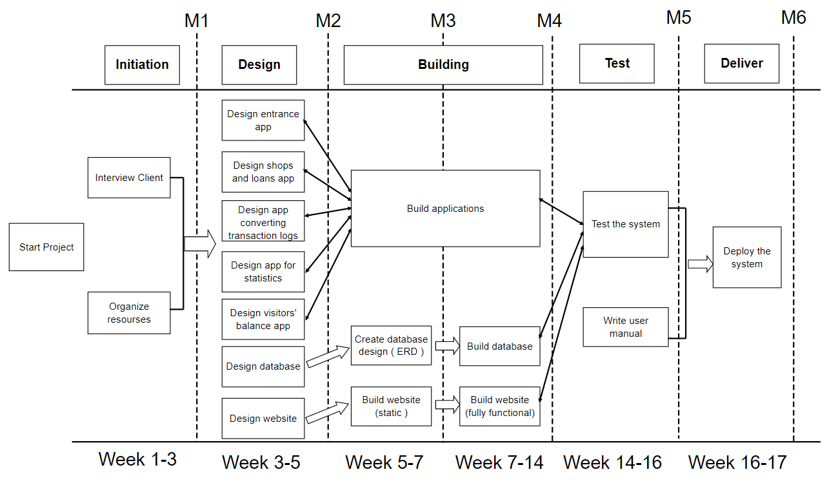Here, the phases of the project will be described along with the activities and milestones. In “Figure 1” a visual overview is given.

Figure 1 – Activities and milestones.

***Phase 1: Initiation***

The initiation phase has two activities. For each activity the tasks are described.

**Activity: Interview Client**

*Tasks for the activity are:*

* Discuss the features of the applications.
* Discuss problems that may occur.
* Confirm the goal with the client.

**Activity: Organize resources**

*Tasks for the activity are:*

* Organize the team.
* Divide work.
* Kick off meeting
* Estimated duration is 2 weeks.

**Deliverables for milestone 1 are:**

1. Get a good understanding of the problem statement, target customer.
2. Well-structured division of the work among the team members.
3. Detailed project plan

***Phase 2: Design***

The design phase has 3 activities*. Tasks are described below.

*All the application design activities are considered as one.

**Activity: Design applications**

*Tasks for the activity are:*

* Figure out the interactions, and the overall flow of the app.
* Think of a visual design idea and pick the best one.
* Present possible solutions to the client.
* Chose solution to implement.

**Activity: Design database**

*Tasks for the activity are:*

* Think of what information need to be stored in the database.
* Consider interaction between both the website and the applications.
* Brainstorm the possible relations in the database.
* Find and implement the best option.

**Activity: Design website**

*Tasks for the activity are:*

* Research for user-friendly website design.
* Make detailed wireframes.
* Think of the target audience and sitemaps

**Deliverables for milestone 2 are:**

1. Fill in all the visual design details for the app, going pixel-by-pixel, creating a design that users will like.
2. Come up with several ideas for the database design.
3. Make wireframes and have a clear idea of the visual design of the website having the target audience in mind.

***Phase 3: Build***

The build phase includes 1 major activity and 4 minor activities. Tasks are described below.

**Activity: Build applications**

*Tasks for the activity are:*

* Work with C#.
* Implement logic of the program.
* Implement functionalities of the program.
* As soon as there is something to show – tell everybody on the team.
* Test after every change in the code.
* Fix possible bugs.
* After all the functionality has been built, start integrating the design.
* Test if everything is running as it should be.

**Activity: Create database design**

*Tasks for the activity are:*

* Create ERD for the database
* Test the proper work of the database using Normalization.

**Activity: Build website (static)**

*Tasks for the activity are:*

* Implement the HTML and CSS code for every web page.
* Test for possible problems.

**Activity: Build database**

*Tasks for the activity are:*

* Work with either MySQL or Oracle db.
* Create all the tables and relationships properly
* Test if the database work as expected.

**Activity: Build website (fully functional)**

*Tasks for the activity are:*

* Implement the JavaScript and PHP logic.
* Test for possible problems.

**Deliverables for milestone 3 are:**

1. Clear and finished database design.
2. All web pages styled; logic of the website clear.

**Deliverables for milestone 4 are:**

1. The design is implemented, and the application is looking polished.
2. The logic and functionalities of the applications work as intended.

***Phase 4: Test***

Testing phase has 2 activities – testing how applications, website and database work together and writing the user manual.

**Activity: Test the system**

*Tasks for the activity are:*

* Connect the applications to the database.
* Connect the website to the database
* Make a test plan.
* Test how components interact with each other.
* Make a list of the results of the test and update the User Manual.

**Activity: User manual**

*Tasks for the activity are:*

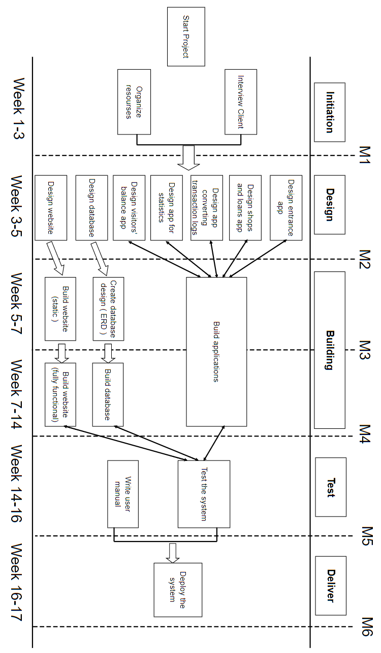

* Write user manual
* Improve the user manual based on the results of the tests.
* Observe users that use the manual.

**Deliverables for milestone 5 are:**

1. Fully tested product.
2. Detailed and user-friendly manual

***Phase 5: Deliver***

Phase 5 has only 1 activity called “Deploy the system”. Tasks are described below.

**Activity: Deploy**

*Tasks for the activity are:*

* Install every software on the corresponding device.
* Distribute the user manuals.

**Deliverables for milestone 6 are:**

1. Deployed C# applications.
2. A deployed website.

## phasing